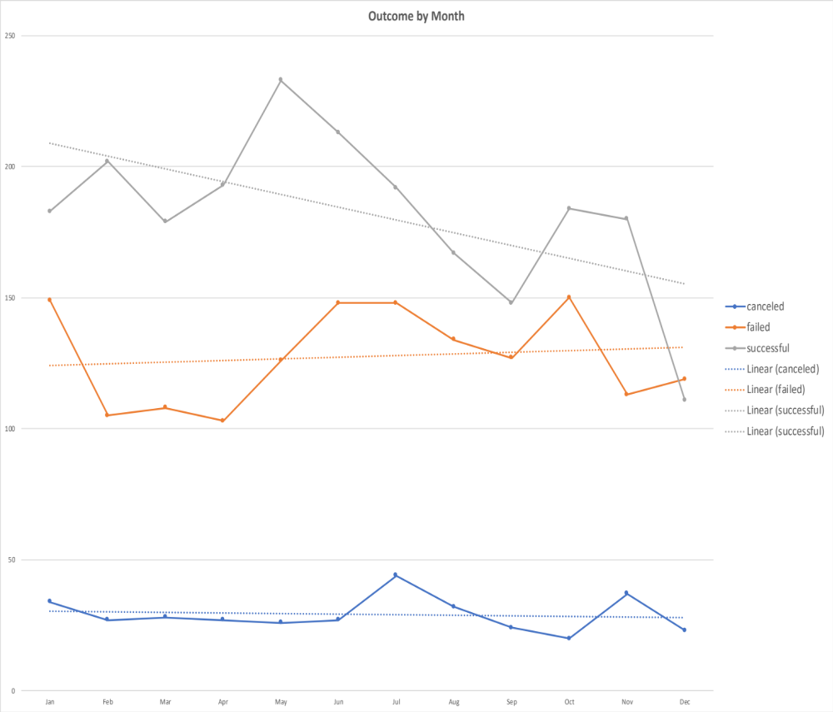

- Outcome by Month Trend

- Overall, projects started earlier in the year are more likely to succeed. The success rate steadily declines month over month.
- Canceled and failed projects follow the same trend line month over month.

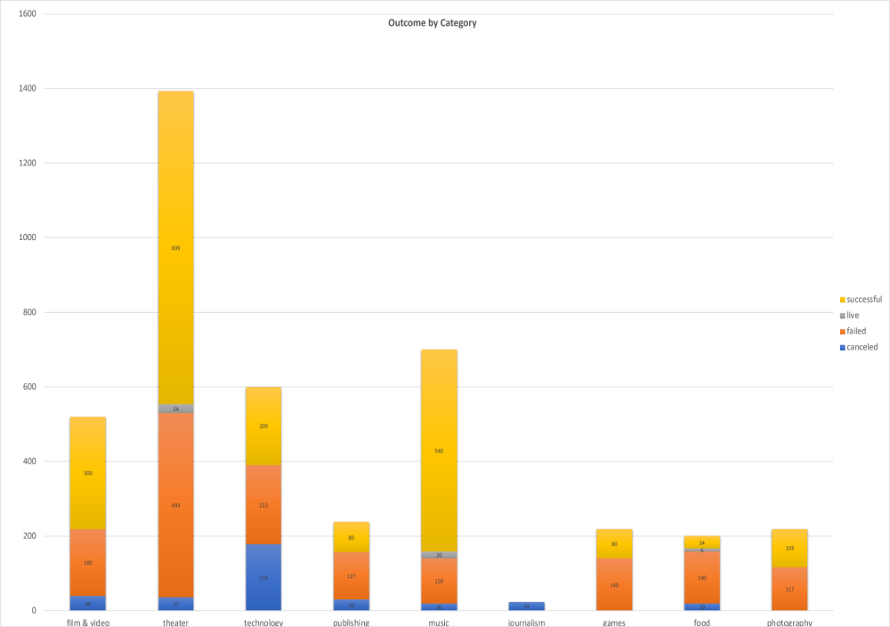

- Outcome by Category

- Theater projects were the most popular and most successful: over half of the projects in this category were successful.
- Theater projects also show the highest go live rate across all categories.

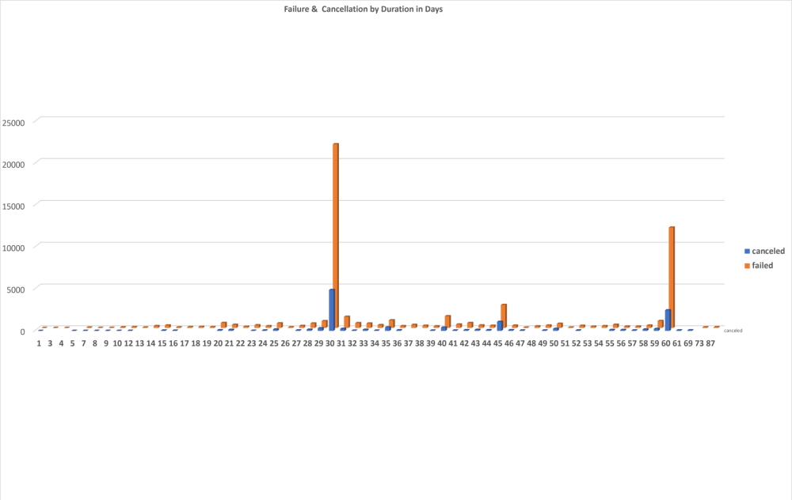

- Failure and Cancellation Decision Points

Overall, cancellations and failures occurred mainly in 30-day intervals: monthly assessment!

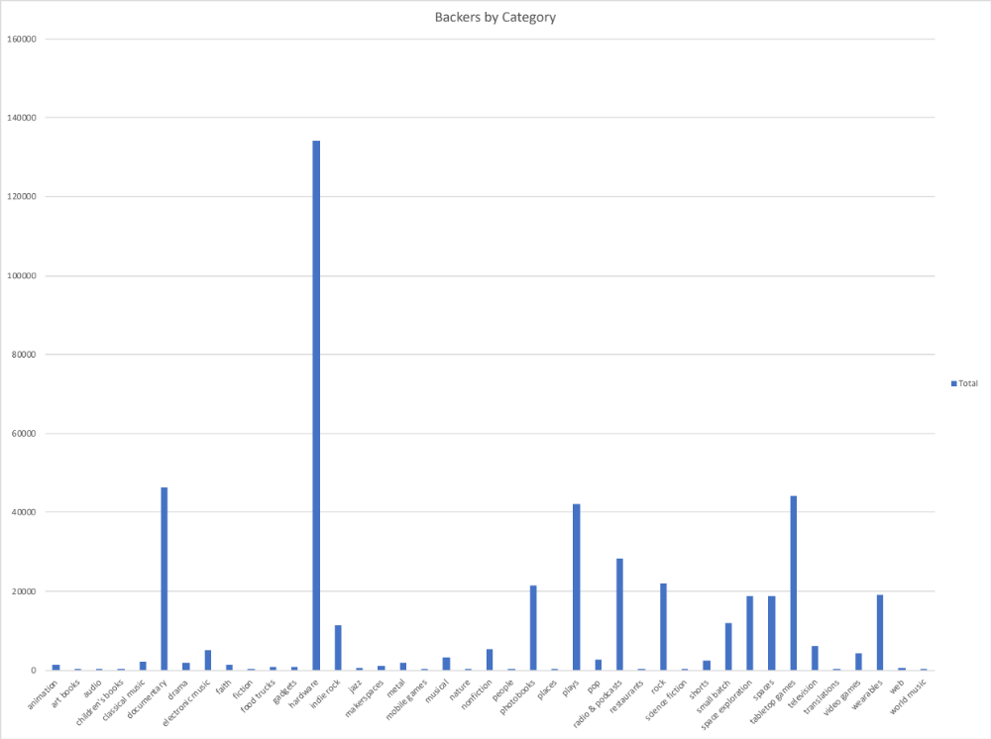

- Backers by Category

Overall, hardware related projects got most backing.

Limitations of the Data Sheet
- Since no reason is given for success, failure or cancellation, no conclusion can be drawn as to why some projects succeed when other fail or cancelled.

